PUNTARELLE & CO

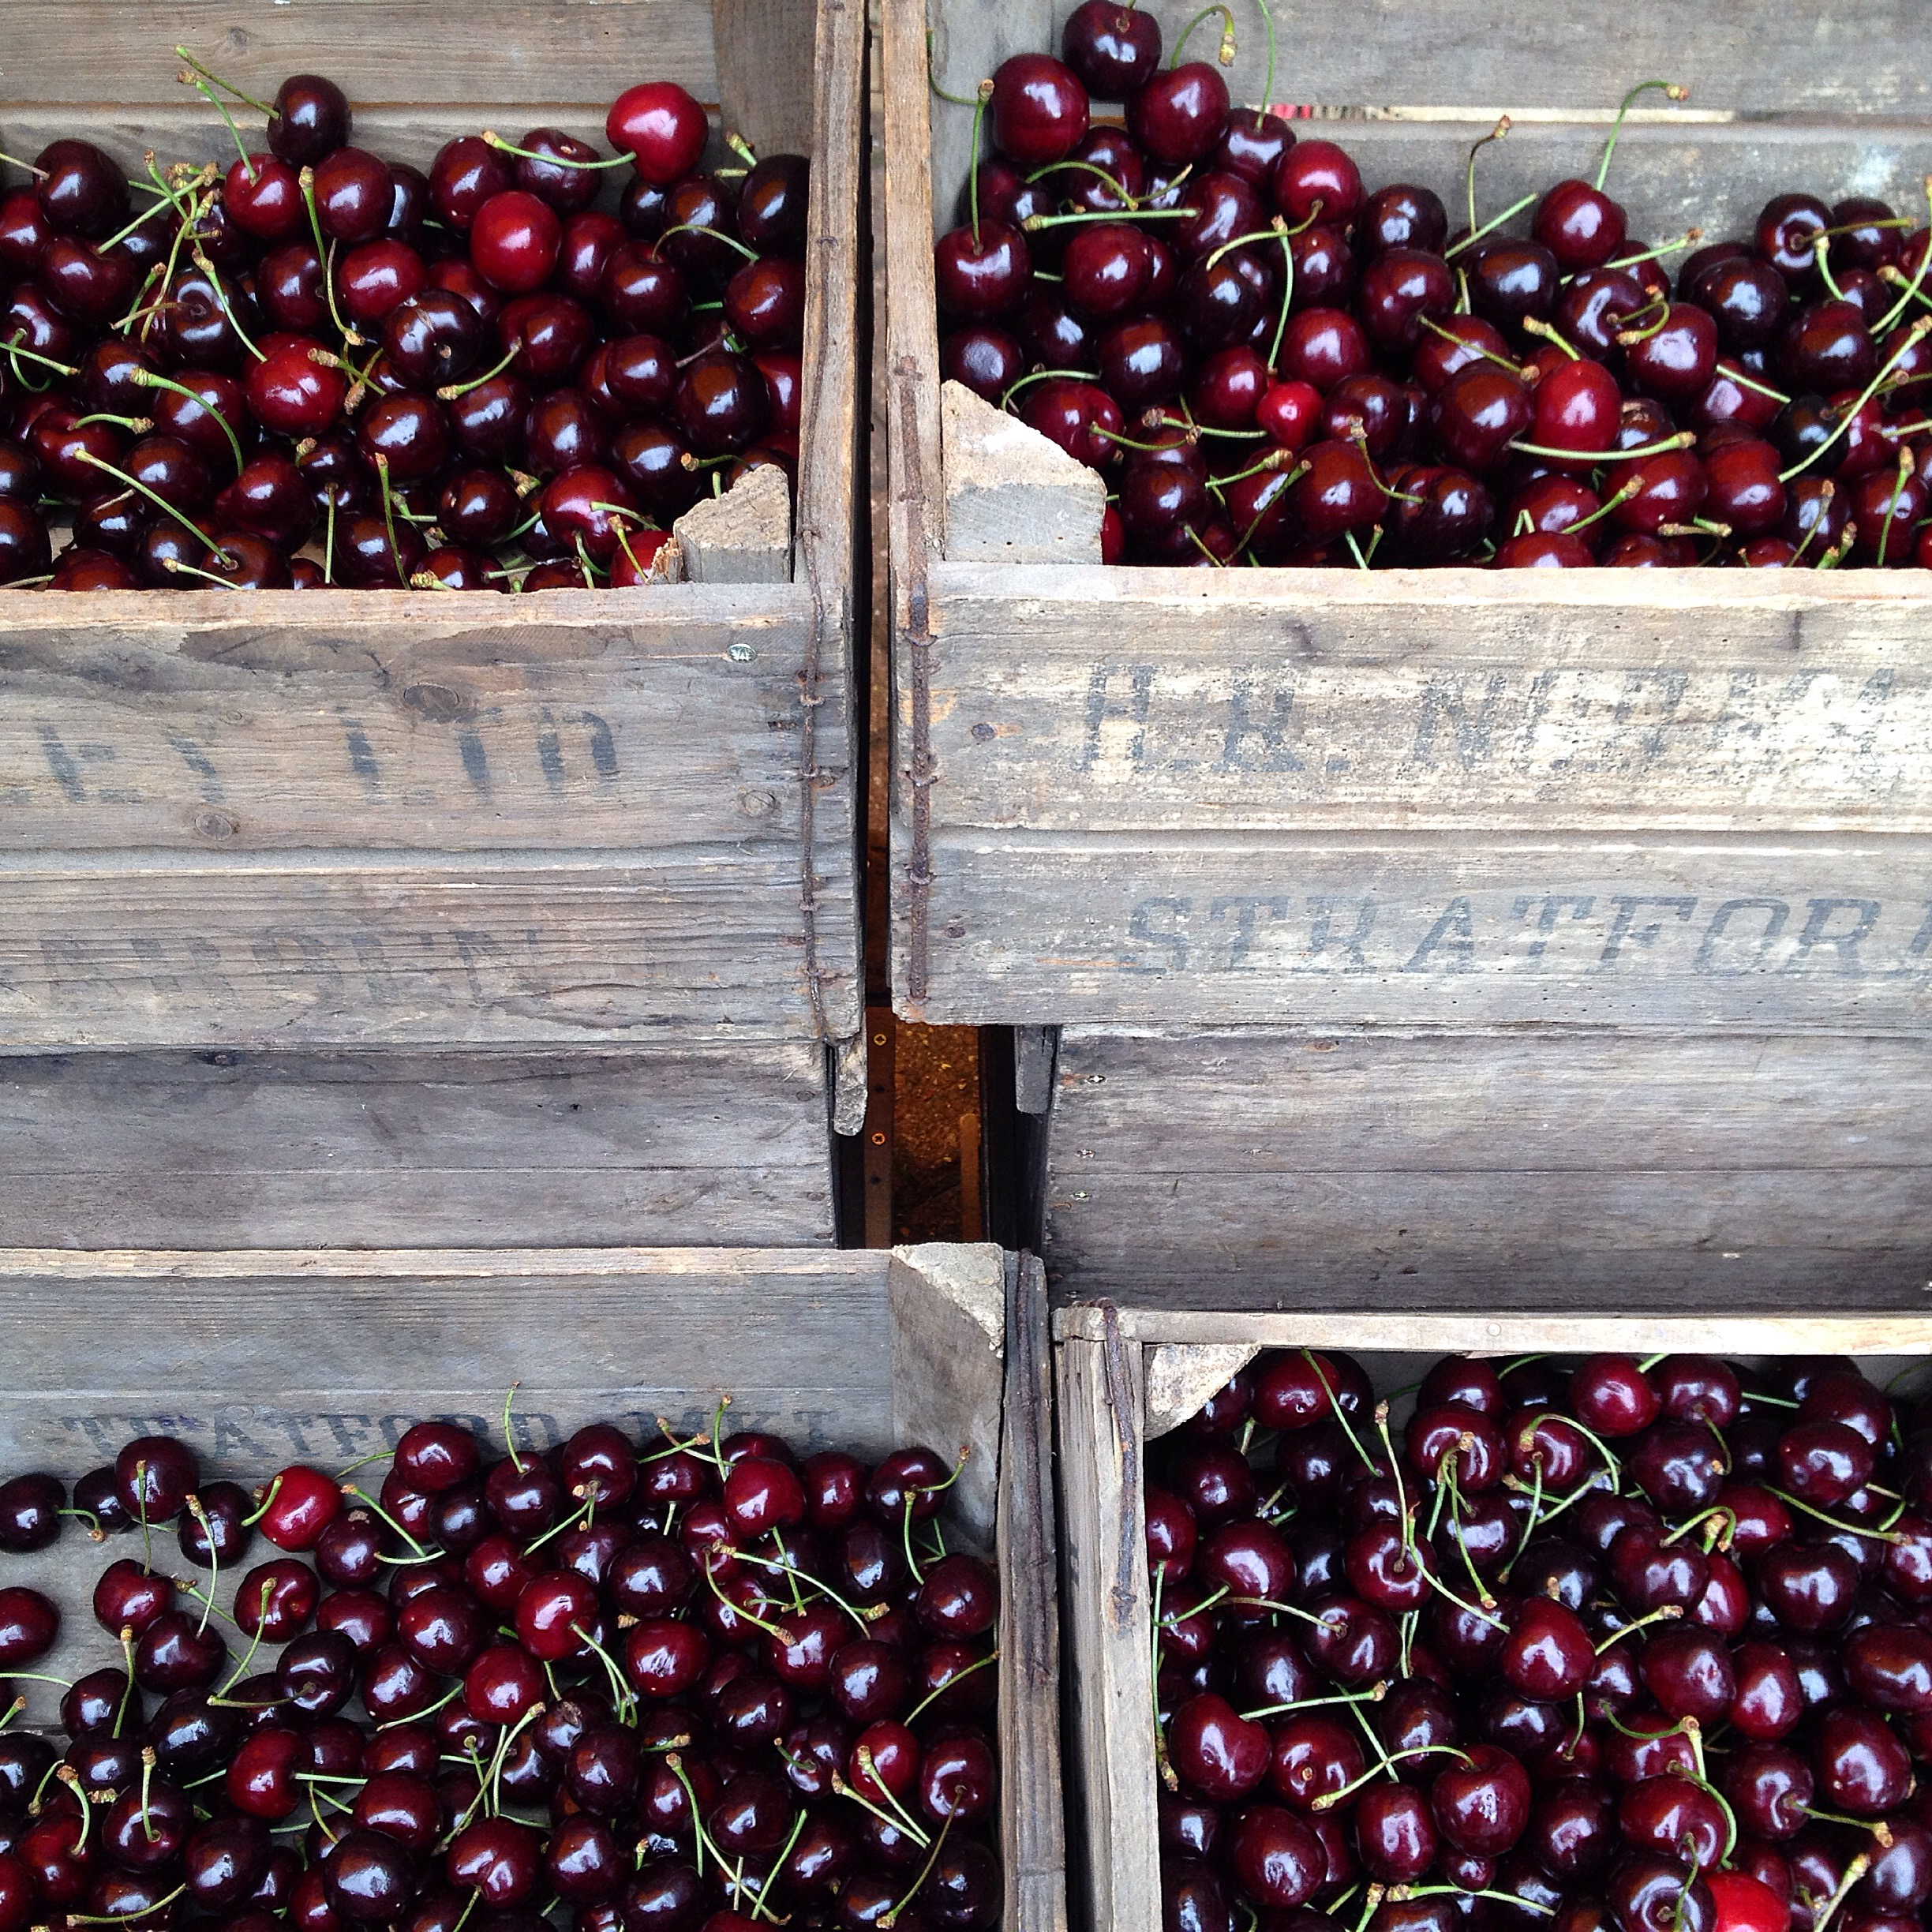
English Cherries
Photo ©Evie Saffron Strands

Cherries

Until recently Cherries were one of the few fruits that still had a short season. Though we’d love to have Italian Cherries for our customers, mostly the varieties are quite small and travel badly. We usually begin with French Cherries around the second week of June. French White Rainier Cherries, in particular, are scooped up by customers as quickly as they come through the door. In England the outdoor grown cherry harvest is traditionally short, sharp and sweet, beginning towards the end of June and over in a matter of 6-8 weeks. In recent years dwarf varieties have been grown in plastic tunnels, which is why you can find some European cherries as late as September.

Best grown in temperate climates, to do well the trees need a chill winter, frost-free during flowering and, later, warmth to ripen the fruits. What they don’t like, as they ripen, is too much rain. This causes the fruits to split open. They are still tasty but won’t keep so well. Sadly we see only a small number of the over 300 varieties of English Cherry but the harvests from Kent this year have been excellent. From the white varieties such as ‘Napoleon’, with its firm flesh and perfect balance of sweetness and acidity, through to the juicy deep reds like ‘Penny’ and ‘Sweetheart’.

White Cherries are best eaten just as they are. Red varieties are delicious this way too but are also good when cooked. They have an affinity with almonds and cracking open a cherry stone reveals a tiny almond-flavoured kernel. Leaving the stones in the fruit for cooking brings out that slight almond quality which is why puddings like Cherry Clafoutis often use unpitted cherries. A Cherry Frangipane Tart is a very good idea and cherries preserved in eau de vie are perfect to break out in winter for a reminder of summer.

