PUNTARELLE & CO

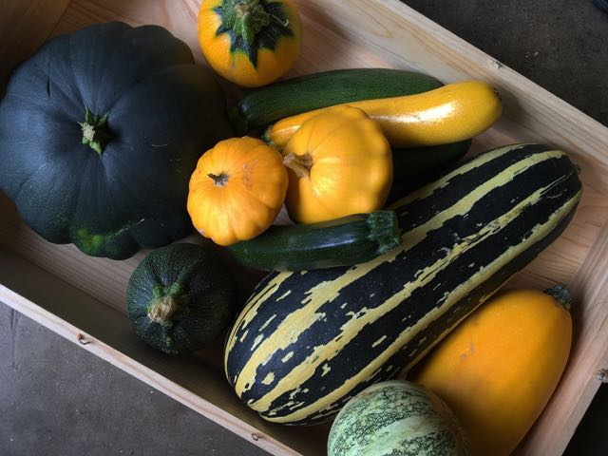
Courgettes and other Summer Squash
Photo ©Evie Saffron Strands

Courgettes and other Summer Squash

Courgettes come under the category of Summer Squash which are all fruits of the Cucurbita family. They are with us until late autumn culminating in large marrows suitable for stuffing, then the hard-skinned varieties take over to see us through winter. They range from the most familiar long, thin, smooth-skinned fruits which come in dark green, yellow and white/pale green, through the distinctly ridged Cocozelle to the round tennis ball sized ‘Ronde’ types which can be very pale to dark green. The round, scalloped Pattypan and pale yellow Crookneck are Summer Squash too and then there is the Spaghetti Squash. The family also includes the Tromboncino, a long, slender, sinuous pale-green squash. Its dense, tasty flesh is particularly good sliced and eaten raw. When we can get it we bring this in from Italy but its trombone-shape makes it an inefficient squash to transport so most remains for home consumption.

Late spring/early summer sees the squash flowers starting to appear on our shelves. They are good tossed in hot butter with new season vegetables or stuffed with ricotta, dipped in a light tempura batter and deep fried. A little later they arrive with their tiny fruits attached and are delicious given the same treatment but without any stuffing. The fruits are versatile. They can sliced, layered with tomatoes and basil and baked for a gratin, added to a vegetable stew like Ratatouille, or chopped and used for a risotto, adding a few sliced blossoms at the end if you have them. They make a surprisingly creamy textured soup cooked up with a little onion and potato – a handful of basil, dill or fennel leaves adds flavour. Chop and fry with onions in olive oil, add oregano, thyme or basil, maybe a little cream or an egg, and you have a pasta sauce. The Italians have a simple and delicious way with fried courgettes – Zucchini Scapece – meaning courgettes marinaded in vinegar and mint. Sliced thinly, Summer Squash are delicious served raw paired with ricotta or goat’s curd and toasted pinenuts or hazelnuts. They can also be stuffed and baked, but maybe that’s best kept for the large marrows.

As yet we’ve never been offered any English grown Tromboncino but by mid-August we are well into the English courgette and summer squash season with lots of interesting and tasty varieties coming through our doors.

