PUNTARELLE & CO

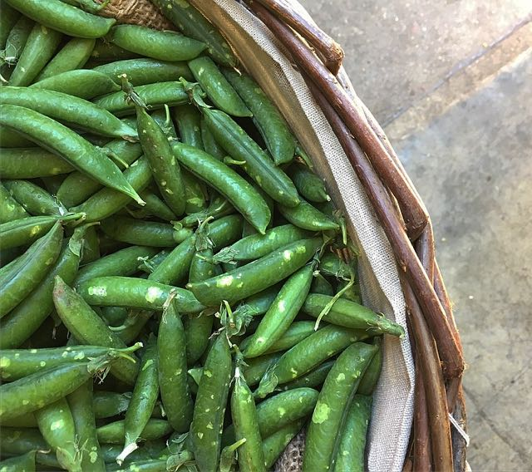
English Peas
Photo ©Evie Saffron Strands

English Peas

As the summer heat increases, the chance to buy good fresh English Peas in their pods decreases. While the edible ‘eat-all’ (mange tout) varieties will happily continue to grow, podding peas will rush to the finish line unless summer goes into reverse and brings cooler weather. This being England, we wait to see.

For decades the vast majority of our home-grown Peas have been harvested for fast-freezing. An excellent way to preserve their sweetness when it’s not possible to get them to market speedily - their natural sugars break down so quickly. But raw fresh peas in their pods are a late spring/early summer treat and good English ones are well worth seeking out. They should look shiny, feel firm and squeak when the pods are rubbed together. Firm, well-filled pods with small to medium sized peas of exceptional sweetness are what we hope for to take over from the Italian ones.

You could eat them straight from the pod, maybe alongside a slice of Ewe’s milk cheese (Berkswell is good); with a slice or ricotta or scoop of goat’s curd cheese accompanied by toasted bread and a dash of olive oil; cook in a classic Italian rice and peas dish of Risi e Bisi, using the pods to make stock; stew them in a French classic mix of peas, lettuce, spring onion and herbs Petits Pois à la Française; or if they are small, simply boil the pods until tender and eat them whole dipped in melted butter.

