PUNTARELLE & CO

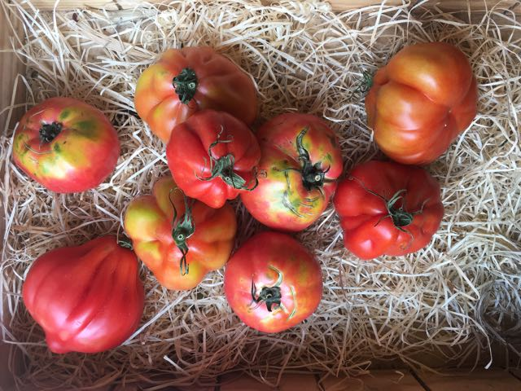
Tomatoes
Photo © Evie Saffron Strands

Tomatoes

What started out as small bitter berries growing wild in western desert areas of South America, were domesticated by the Aztecs and transformed into tomatl (plump fruit). Despite the fact Tomatoes were first brought to Spain from Mexico in the 15th century, they were viewed with suspicion here until the 19th century. We took much more readily to the imported potatoes and tobacco, despite the fact all three belong to the same plant family – Nightshade. It was the tomato’s perceived resemblance to Deadly Nightshade that held up our acceptance of what is now a firm favourite on our continent.

Good Tomatoes are the defining taste of summer and now is the time eat your fill and preserve, preserve, preserve. The tastiest tomato is rarely the best-looking one – but then beauty is in the beholder. The more imperfect its appearance, the more interesting its flavour can be. Store them stalk-side down on your kitchen counter, not in the fridge, to enjoy them at their most flavourful. We source most of our tomatoes from Italy and France but when growing conditions are right – as they surely are this year – we buy English ones too. Now, in late July, Italy is to the fore. You will find the Sorrento, grown in the rich volcanic soil around Mount Vesuvius - don’t be fooled by their scarred appearance, their fleshiness and taste is exceptional; the meaty Cuore di Bue (ox heart), originally grown in Liguria, are coming in from Sicily now; Cherry and Datterini are here too. As I write we are keeping our eyes peeled for good English tomatoes for this week’s selection.

The Tomato’s relatively low-sugar content for a fruit (3%), along with its high amounts of savoury glutamic acid, is why we treat it most often as a vegetable. Rich in Vitamin C, the red varieties deliver a high does of the antioxidant Carotenoid Lycopene. Studies have shown that concentrating tomatoes down into a paste or sauce makes the antioxidant particularly potent.

The sweet/acid character of tomatoes pairs particularly well with herbs like basil, marjoram/oregano, and thyme. The tomato appreciates salt and salty foods like anchovies, cheese and olives and a cream tempers its acidity. In the current hot weather thoughts turn to a soothing cold tomato soup; or peppery Gazpacho; a no-cook Middle Eastern Fattoush bread salad or Greek Feta salad; or simply selecting the ripest tomato in your bag, slicing it, adding salt and a good olive oil.

With a little cooking you could have Simon Hopkinson’s Creamed Tomatoes on Toast; a Tomato Risotto – I like the suggestion from Rachel Roddy in her ‘A Kitchen in Rome’ column for The Guardian Cook to add a shot of Martini Rosso for a “nip of sharp sweetness”. https://www.theguardian.com/lifeandstyle/2018/jul/23/rachel-roddy-recipe-tomato-risotto
You could stuff large tomatoes with rice and bake them slowly in the oven; make a mousse, a sauce or even a jelly. Bring out the tomato’s fruit nature and make it into a dessert. Kitty Travers includes a recipe in her La Grotta Ices book ADD A LINK TO THE BOOK IF YOU LIKE for Tomato and white peach sorbet which emerges an elegant shade of shell pink, tasting softly sweet and fruity – just the thing for cooling down in this incredibly hot summer.

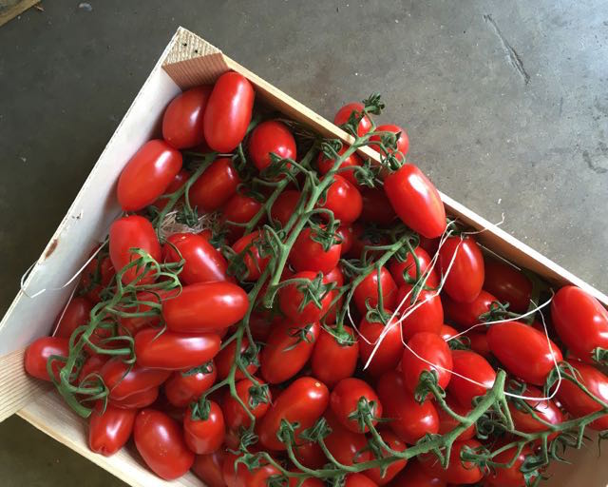
English Baby Plum Tomatoes
Photo © Evie Saffron Strands

