PUNTARELLE & CO

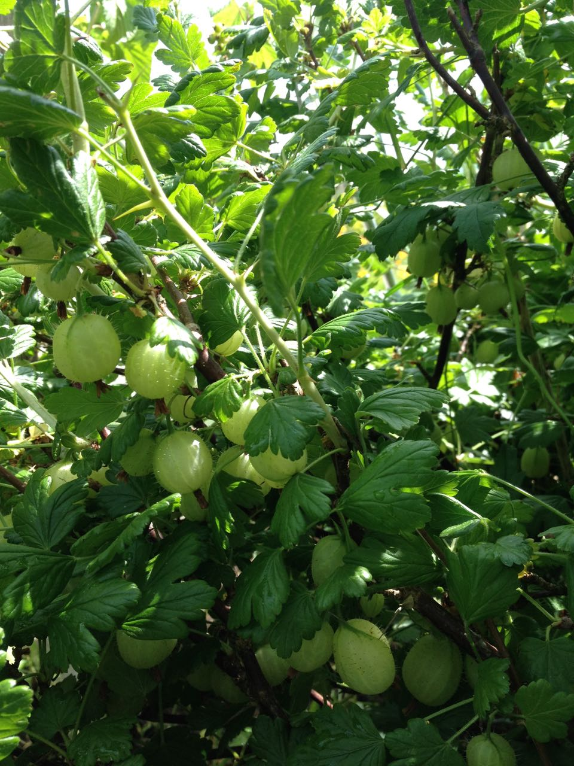
Gooseberries
Photo © Evie Saffron Strands

Gooseberries
Currants and Gooseberries are all species of the genus Ribes and are cold climate fruits, growing most happily in Northern Europe and North America. Gooseberries grow best in cool, damp conditions so the UK is excellent for them. They are normally the first fruits of Spring and the bushes can remain productive into August. The first fruits are sharp, hard and green and need plenty of sugar, but it’s then that their unique flavour is most pronounced. If you want a sweeter gooseberry, wait a few weeks for the green globes to mellow to a pale green/gold or go for a red variety like Pax. Given a bit of heat and sun, later in the season you can reduce the amount of sugar you need to add to them.

This week we have our first gooseberry harvest from our preferred farm in Kent so you can see for yourself how they develop as the season progresses.

Gooseberries pair wonderfully with elderflowers, imparting a muscat flavour, and the Elder usually produces its flowers at just the right time for the first gooseberry harvests. Just add a flower head to the poaching pan. The fruits are packed with vitamin C, and are rich in pectin, so they are excellent for jam-making. Made into a sharp compote or chutney they are excellent for cutting oily fish such as mackerel, or fatty meats like pork or goose. The possibilities for puddings are many, from crumbles, tarts, jams, jellies, syllabubs and fools to sorbets, parfaits and ice creams. They make a fine Eton Mess-like pudding and are gorgeous baked into a buttery-pastry pie. Keep in mind that Gooseberries love cream.

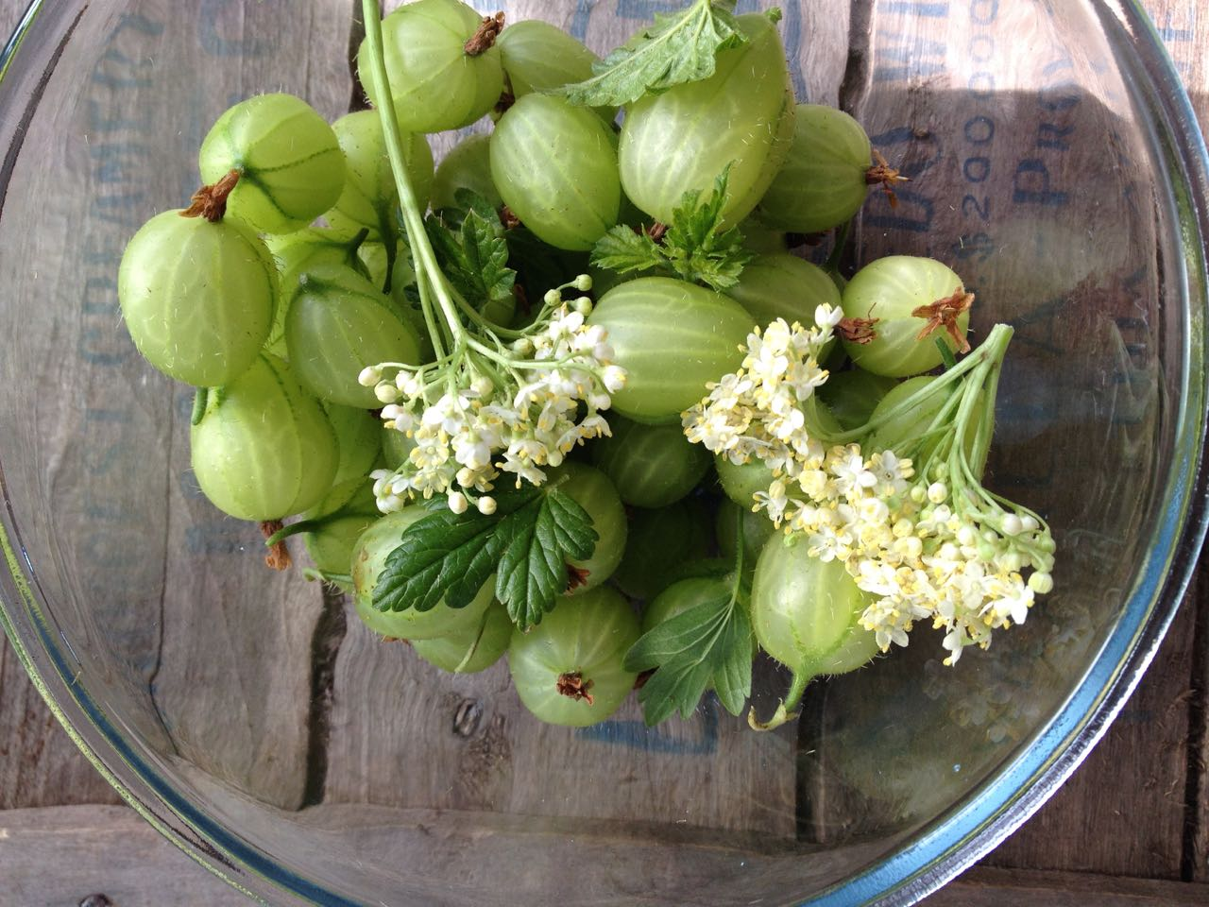
Gooseberries and Elderflowers
Photo © Evie Saffron Strands

